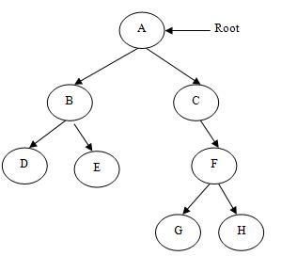
what is difference between graph and tree?

Tree is special form of graph i.e. minimally connected graph and having only one path between any two vertices.

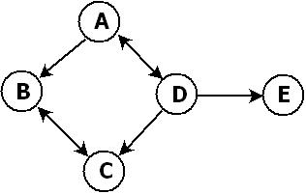
In graph there can be more than one path i.e. graph can have uni-directional or bi-directional paths (edges) between nodes

